Data Source 2: Excel spreadsheet

Filter Rows

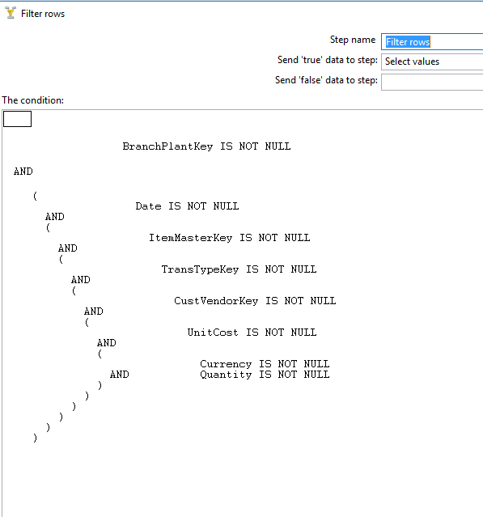

Transformation:

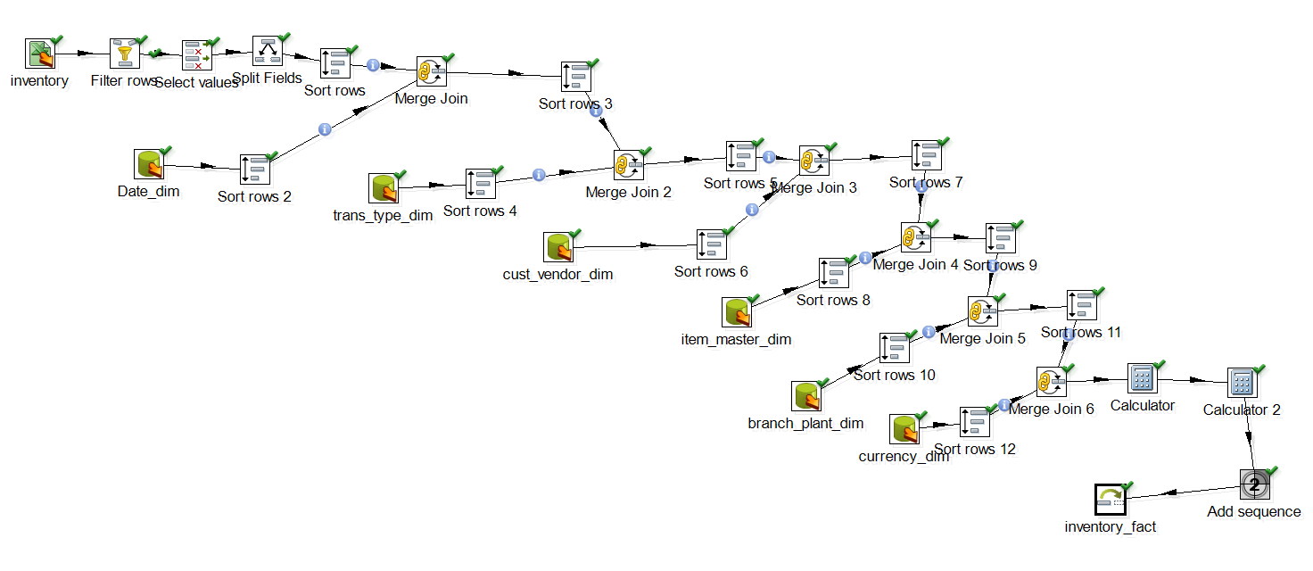

After Transformation,10 rows were inserted.

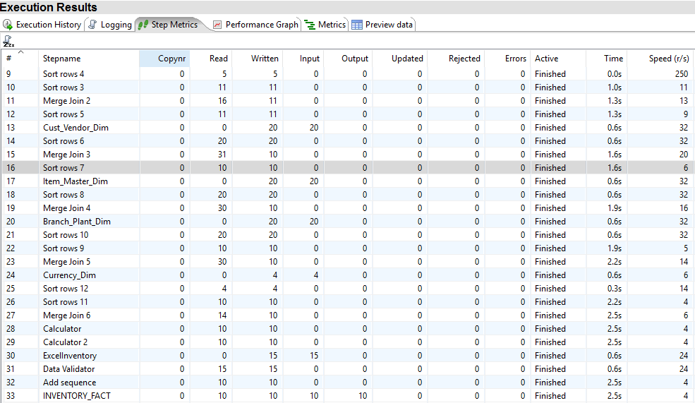

Result:

